MUHAMMAD KASHIF

:

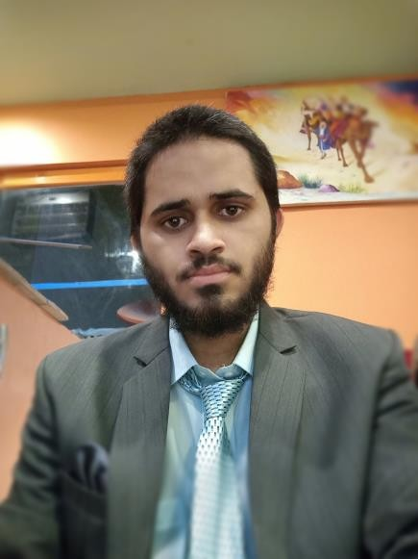

# Contact

Address:

Gulshan-e-Hadeed, Ph-2, BinQasim Town, Karachi.

Phone:

+92-3351801680

Email:

[kashifmohammad726@yahoo.com](mailto:kashifmohammad726@yahoo.com)

# Languages

English – B2 Urdu – C2

# AboutMe

From the moment I produced “Hello World” in the console of my first Application, I knew I was hooked into the world of software development. But software development has never been “just a job” for me, it’s offered an engaging challenge to continually learn and improve my skills in creating high-quality software. When started with a simple “Hello World” has become a full-fledged passion that only gets more exciting as the years go by.

Below you will find projects I’ve completed that showcase my skills and general background in developing software.

# Projects:

[Fortunaze.com](fortunaze.com) : I have worked as a backend developer on this project, I have made the entire project on laravel including the mobile app and CRM.

[Winjoy.ae](winjoy.ae) : I have been part of the development team and built a module on this project using laravel

[Vital Analytics](https://vhs3.vitalanalytics.net/) : I have been working on this project as a full stack developer and also tested the system using Selenium.

VIEW MY PERSONAL PORTFOLIO SITE ([View Portolio](https://silly-easley-6f5b96.netlify.app/))

# Experience

* 6 months as full stack developer and designer at Vital Analytics Software (React + Laravel + Selenium + FIgma)
* 9 months as backend developer at BlueHatWebSolutions

# Programming Languages and Technologies

* Javascript
* PHP
* Html and Css
* React.js
* Laravel
* Selenium
* Figma